BRAHAW Overview
The purpose of BRAHAW is to assist rural and remote AHPs to build their allied health assistant workforce, roles and models of service delivery (promoting viability and reach of their practices), by building a local skilled AHA workforce, and providing a tailored package of practice and workforce support. Together, these two elements will improve community access to allied health services while developing the operational capability to deliver services with currently available under-utilised service and income streams.
Participating organisations will develop and implement a new AHA service delivery model; or revise and improve an existing AHA service delivery model. These service delivery models should aim to increase access of rural and remote communities to allied health services.
To achieve this SARRAH will support participating organisations to address activities within four BRAHAW domains.
Domain 1: Education and certification
Domain 2: Work integration and governance
Domain 3: Supervision and support
Domain 4: Service Model Design
. 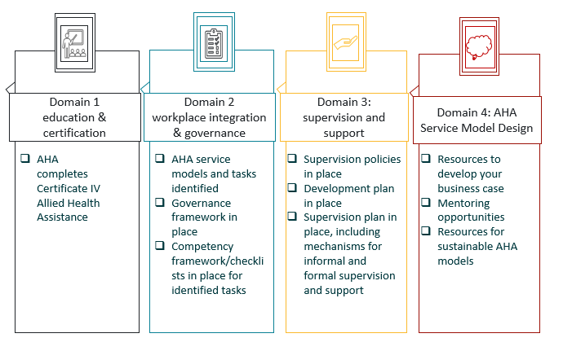

Organisation requirements

AHA service delivery model
Each participating organisation will be required to employ one or two (new or existing) AHA to implement a new, or review and improve an existing model of AHA service delivery.

Development time
The organisation will provide the AHA will 0.2FTE of development time. This time can be used towards work integrated study, work specific skills development, and service development

Governance
The organisation will develop and implement a governance framework guiding the role and scope of the AHA. SARRAH will provide assistance with development of this framework.

Supervision
The organisations will provide formal and informal supervision for the AHA. This supervision will be provided by the allied health professional(s) relevant to the AHA roles. The supervision will be regular and supported by supervision policies and professional development plans. SARRAH will/should be notified in the first instance of any staffing changes that affect supervision provision for the AHA.

Evaluation
The participating organisations will contribute to, and support their staff to participate in routine data collection activities that contribute towards the evaluation of BRAHAW, including but not limited to:
- Surveys and interviews to collect organisational, contextual and qualitative information and to plan appropriate data collection activities for the life of the project;
- data relating AHA service delivery models, and relevant activity
Data collection activities will be planned in collaboration with the participating organisation, an external evaluation and research team and supported by SARRAH project staff.

Reporting
The organisation must provide quarterly activity reports to SARRAH as per template provided.

Eligibility
To be eligible for the program packages the organisation must be:
- a private practice (including sole practitioner) or non-government organisation providing allied health services in rural and remote communities
- Be located within an area classified as per Modified Monash Model as MM 3-MM 7 or be located within an MM2 and provide the majority of your services within MM 3-MM 7 regions.
- Be willing to develop and implement as AHA service delivery model, and meet the requirements listed above.

Education
The AHA must complete their certificate IV AHA with a registered training organisation that is subsidised and has a maximum course length of 18 months.

Funding and supports
SARRAH will provide funding and supports to the organisation during the implementation of BRAHAW
The organisation is entitled to receive:
Purpose | Amount | Comments
Education funds | All course costs will be covered | funding is for the position not the individual.
Workplace training grant | $26,000 | Considers the costs of supervision and on-the-job training and backfill for the trainee.
Travel and accommodation | $2,500 | On agreement with SARRAH, if necessary to attend face to face training or similar

Payments are made prospectively on a quarterly basis.
Individual membership to SARRAH is offered to the rural generalist trainee and their professional supervisor.
In addition to funding, SARRAH will provide support to organisations to identify, develop and implement resources and systems to enable successful AHA service model delivery. These supports may included governance, supervision and business supports.
The support offered by SARRAH will be dependent on the unique circumstances of the organisation applying. See Figure 2 for more details.
Option 1: New Model and Training  SARRAH to provide:  - Funds for AHA Cert IV and workplace training grant  SARRAH to support (as required):  - Organisation plan new AHA service delivery model  - Resources supplied to enable supervision and governance  - Access to relevant online education offerings | Option 3: New Model and Qualified  SARRAH to provide:  - Funds for workplace training grant  SARRAH to support (as required):  - Organisation plan new AHA service delivery model  - Resources supplied to enable governance and supervision  - Access to relevant online education offerings
Option 2: Established Model and Training  SARRAH to provide:  - Education funds for AHA Cert IV and workplace training grant  SARRAH to support (as required):  - Organisation review of AHA service delivery model  - Resources supplied to enable supervision and governance  - Access to relevant online education offerings | Option 4: Established Model and Qualified  SARRAH to provide:  - Funds for workplace training grant  SARRAH to support (as required):  - Organisation review of service delivery model and governance structures  - Resources supplied to enable supervision and governance  - Access to relevant online education offerings

